**1. Full Name of the Work**

**Sado24**

Telegram Bot Beta Version: [*Explore*](https://t.me/sado24bot)

**2. Name of the Team and Technology Stack Used**

- **Database**: PostgreSQL

- **Backend**: Python

- **Libraries**: Telebot (for Telegram bot integration)

**3. Project Purpose**

Sado 24 is a platform that brings together all podcasts in one place.

**4. Conceptual Model**

* Choose a preferred language
* View and listen to all podcasts
* Listen to podcasts by specific topics
* Listen to episodes of selected podcasts
* Use time stamps for easy navigation
* View and listen to top podcasts
* Get quick summaries of podcasts with AI
* Quickly find topics with AI
* Follow podcasts
* Save podcasts
* Filter podcasts by your interests
* **Supported Languages**:
  + Uzbek, Russian, English

**4.1 Functional Requirements**

The podcasts section works through an admin panel, where podcasts go through moderation.

**4.2 Application Structure Requirements**

No specific external system integrations or authentication requirements.

**4.3 User Classes**

- Regular users (listeners)

- Admins (for podcast moderation)

**5. Project Diagram**

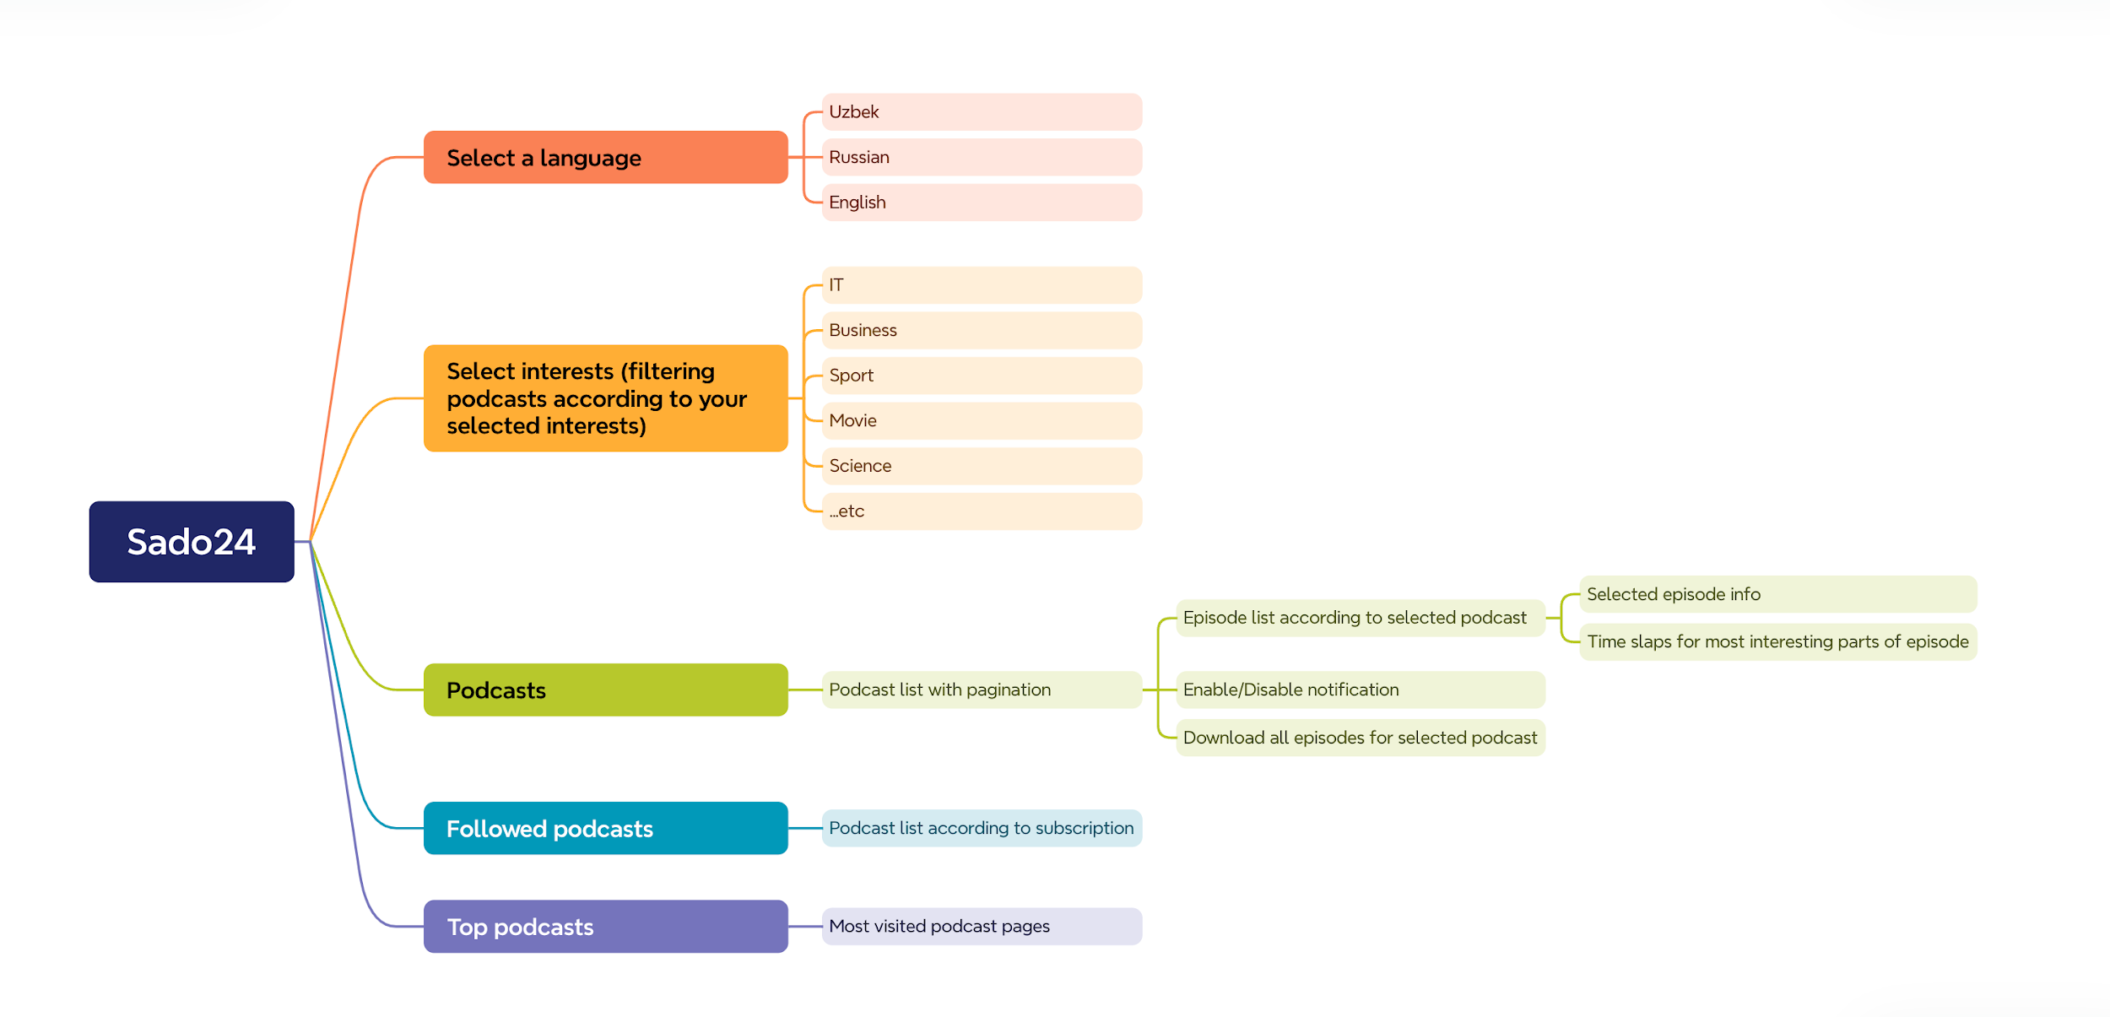

**6. Integrations**

- Telegram bot (via Telebot library)

**Participant Roles:**

- IBROKHIM ABDURAKHMONOV - Product Manager

- JAMSHID MA'RUF - Backend Developer

- MUHAMMAD UMARQULOV - Web Developer, Backend Developer

**7. Additional Information**

- *Database Diagram*:

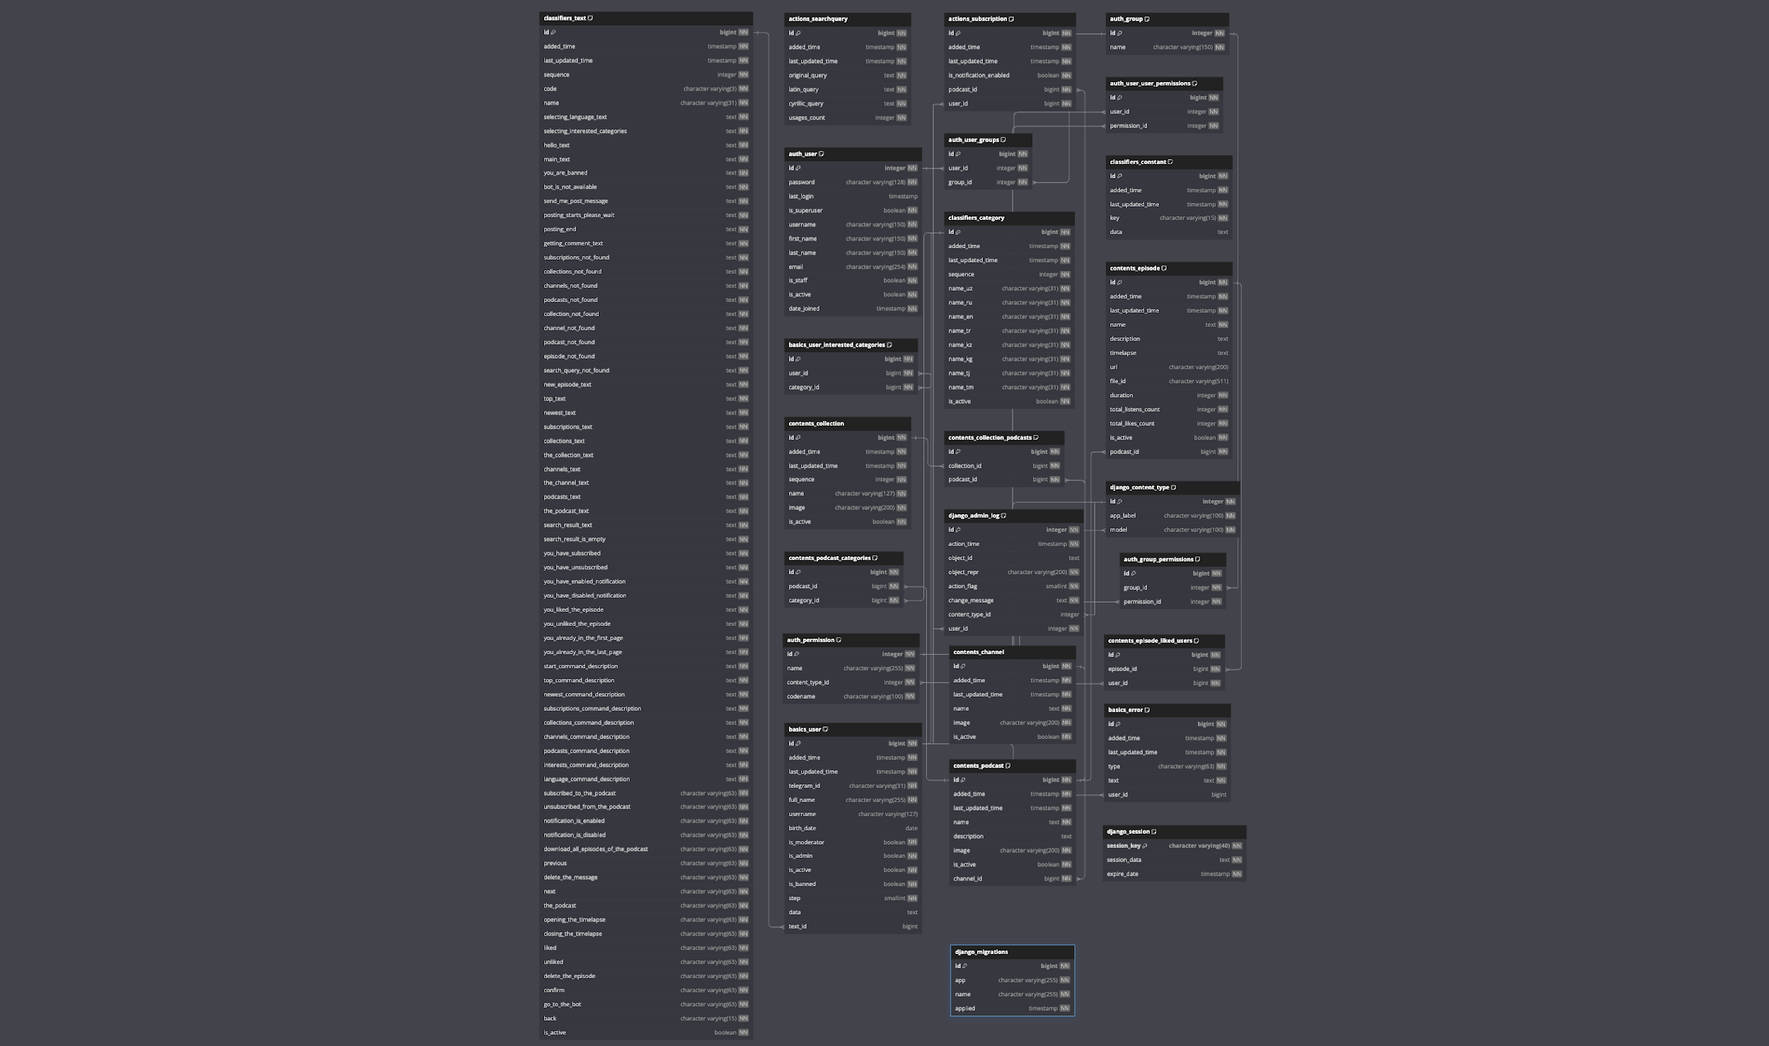

- *Mobile Application Designs Preview*:

